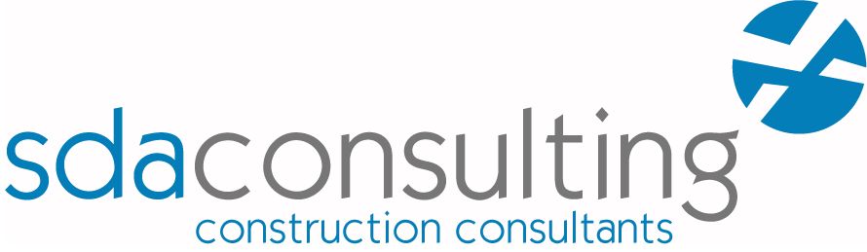
Vacancy: Clerk of Works
Recruiter: SDA Consulting LLP
Location: Manchester
Hours of Work: Part Time / Flexible Working
Salary: Negotiable

Job description
SDA Consulting LLP is looking for a Clerk of Works to support its work across a diverse range of construction projects across the North West. SDA Consulting LLP is one of the leading independent Construction Consultancies in the North West. We offer a comprehensive range of services including Project Management, Quantity Surveying/Construction Cost Management, Building Surveying and Clerk of Works services. We have extensive experience in both the public and private sectors.
Role Requirements
- To be responsible for inspecting, monitoring, and reporting on the quality and progress of work.
- To have thorough technical knowledge of construction methods, construction processes, building regulation requirements and relevant health and safety standards.
- To familiarise themselves with and to understand relevant drawings, specifications and schedules forming the building contract;
- To perform regular site inspections to monitor progress and quality of works on site, checking that site operations and construction works comply with the relevant contract documents and statutory requirements.
- To provide written weekly reports on quality and progress, with photographic records. Report writing should be of a high standard in terms of both content and format.
- To attend monthly project progress meetings where required during the construction phase.
- To assist with handover processes and perform snagging and defect inspections as required under the contract;
You should:
- Have a proven track record of successfully carrying out the Clerk of Works role;
- Ideally:
  - Be a member of a relevant professional body such as the Institute of Clerks of Works and Construction Inspectorate, Chartered Institute of Building or Royal Institution of Chartered Surveyors;
  - be North West based;
  - have PI Insurance cover in place or be willing to put this in place.
- Have excellent verbal and written presentation skills and ability to produce reports to a professional standard;
- Be able to develop good working relations with project team members on each project;
- Be able to use Microsoft Word, email and online document management systems to review drawings, specifications and schedules;
Those interested in working with SDA Consulting LLP in a flexible capacity should send their CV/Profile to recruitment@sdaconsulting.co.uk. Please include your hourly/daily rate.
SDA Consulting LLP are committed to equality and diversity and welcome applicants from everyone who has the necessary skills and qualities.
What we will use your data for and how long we will keep it - Unless you inform us otherwise we will hold your CV for 12 months from your enquiry for the purpose of considering you for our opportunities. We will not provide your CV to any third parties and will treat all applications in confidence. By applying you agree to these conditions but if you would prefer us to only hold your personal data for this vacancy, please email recruitment@sdaconsulting.co.uk.

